**Bookstore-Management-System Using MERN Stack**  
  
**Team Members**  
  
**1.ARJUN J**  
**2.ARUN KUMAR P**  
**3.ARUN KUMAR M**  
**4.ASHIK PRAKASH**  
  
**Institution: TJS Engineering College**

<https://github.com/ArjunJ-7/book_store_using_MERN_stack>

### **Abstract:**

The **bookstore-Management-System** is a web-based application designed to simplify the process of browsing, purchasing, and managing books through an efficient and user-friendly platform. Built using the MERN stack (MongoDB, Express.js, React.js, Node.js), the system enables customers to easily search for books, add them to their cart, and complete purchases, while store administrators can manage inventory, track orders, and update book details effectively. The platform also supports user authentication and role-based access control to ensure security and privacy.

The system is designed to cater to both customers and bookstore administrators, offering a seamless interface for browsing books, managing purchases, and keeping track of inventory. The project emphasizes scalability, performance, and security, incorporating technologies like JWT for authentication and bcrypt for password encryption. It also features a responsive and mobile-friendly design to ensure accessibility across all devices.

This report explores the system's functional and non-functional requirements, system architecture, database design, and API design, along with detailed steps on implementation and deployment. Additionally, it outlines the security features integrated into the application, such as JWT authentication and role-based access control. Furthermore, the report discusses testing methodologies including unit and integration tests, and explores challenges faced during development, along with their solutions. The final section looks at future enhancements and the potential for expanding the system's features, such as introducing advanced recommendation systems or integrating with third-party sellers.

The **bookstore-Management-System** offers a robust solution for improving the efficiency of book management, contributing to better service delivery in the bookstore industry, and providing an enhanced user experience for both customers and administrators.

### **1. Introduction:**

#### **Project Overview:**

The **bookstore-Management-System** is a comprehensive web application designed to streamline the process of browsing, purchasing, and managing books. This system provides a platform for customers to search for books based on various criteria, such as genre, author, or price range, and place orders. Additionally, it allows bookstore administrators to manage the inventory, update book details, and track customer orders.

#### **Purpose and Motivation:**

With the increasing number of online book purchases and the demand for seamless shopping experiences, traditional methods of managing bookstore operations can often lead to inefficiencies, such as inventory mismanagement and long order processing times. This project is motivated by the need for a digital solution that enhances the customer shopping experience while improving the efficiency of managing a bookstore's inventory and order processing.

#### **Objectives:**

The key objectives include creating an easy-to-use interface for customers to search and purchase books, secure access for both customers and administrators, and tools for administrators to manage the bookstore’s inventory. The system places a strong emphasis on scalability, usability, and security to provide a robust and efficient platform for both customers and bookstore staff.

#### **Target Audience:**

The primary users of the **bookstore-Management-System** are:

* **Customers**: People searching for books and making purchases.
* **Bookstore Administrators**: Individuals managing the inventory, order processing, and customer interactions.
* **Administrative Staff**: Those overseeing the system's operation and ensuring it runs smoothly.

### **2. Project Requirements:**

#### **Functional Requirements:**

* **Customers**:
  + Register/login, manage personal profiles, browse and search for books by genre, author, or price, add books to the cart, place orders, and view order history.
* **Bookstore Administrators**:
  + Register, update personal profiles, manage inventory (add, remove, or update book details), view customer orders, and update order statuses (e.g., shipped, out of stock).
* **Admin**:
  + Oversee user management (customers and administrators), monitor system performance, verify orders, and ensure inventory is up to date.

#### **Non-Functional Requirements:**

* **Performance**:
  + Handle high user traffic, including multiple customers browsing and purchasing books at once, and execute searches efficiently.
* **Reliability**:
  + Ensure system availability and minimize downtime to provide a seamless shopping experience for customers.
* **Security**:
  + Implement JWT for secure customer and admin authentication, encrypt passwords, and follow best practices for securing user data and transactions (e.g., payment details).
* **Scalability**:
  + Design the system to easily expand with an increasing number of books, customers, and features like new payment gateways or recommendation systems.
* **Responsiveness**:
  + Provide a UI that adapts smoothly across different devices and screen sizes, ensuring a consistent shopping experience on desktops, tablets, and smartphones.

### **3. System Architecture:**

The system architecture of the **bookstore-Management-System** is designed to ensure smooth interaction between the frontend, backend, and the database. The architecture follows a client-server model, using the MERN stack (MongoDB, Express.js, React.js, Node.js). Below, I will elaborate on the architecture and include details on the various components involved.

#### **Architecture Overview:**

The architecture can be broken down into three major components:

* **Frontend (Client-side)**: React.js
* **Backend (Server-side)**: Node.js with Express.js
* **Database**: MongoDB

These components work together to facilitate communication between the user and the system, making it easy to browse, purchase books, and manage inventory.

#### **1. Frontend (React.js):**

* **Role**:

The frontend handles the user interface and ensures smooth communication with the backend via API calls.

* **Components**:
  + **React Components**:

These include UI elements such as buttons, forms, product cards, search filters, and the shopping cart used by customers and administrators. Components are reusable and state-driven to provide a dynamic experience.

* + **State Management**:

The application uses React’s state management for storing the user's session, cart data, order history, and dynamic UI updates (e.g., displaying available books, price updates, etc.).

* + **API Integration**:

Axios or the Fetch API is used to make asynchronous requests to the backend for data retrieval, such as searching for books, updating inventory, placing orders, and managing customer profiles.

* + **Routing**:

React Router manages navigation within the app, allowing users to seamlessly move between pages like the homepage, book search, product details, checkout page, and user dashboard.

* **User Interaction**:
  + **Customer Side**:

Customers can log in, browse books by genre, author, or price range, add books to their cart, place orders, and view their order history.

* + **Admin Side**:

Administrators can manage the bookstore’s inventory (add, remove, or update book details), view customer orders, update order statuses (e.g., processed, shipped), and manage system settings.

* + **Admin Panel**:

The admin panel allows bookstore staff to monitor inventory, oversee customer orders, and manage other system functionalities like user roles or store settings.

### **2. Backend (Node.js + Express.js):**

#### **Role:**

The backend provides the core logic of the application, handles requests from the frontend, and interacts with the database to manage book listings, customer orders, and user profiles.

#### **Components:**

* **Node.js**:

Node.js is a JavaScript runtime that allows the server to run JavaScript code. As a non-blocking, event-driven runtime, it is highly efficient in handling multiple customer requests simultaneously, such as browsing books, placing orders, and managing inventory.

* **Express.js**:

Express.js is a web framework for Node.js that simplifies the development of APIs. It provides routing, middleware, and error handling. Express.js enables the system to expose RESTful endpoints to handle tasks such as user registration, book browsing, order placements, inventory updates, and more.

#### **Key Features:**

* **Authentication**:

The backend handles user authentication using JWT (JSON Web Tokens). Once a user (customer or administrator) logs in, the server generates a JWT, which is used to authenticate subsequent requests. This ensures secure access to protected routes, such as placing an order or updating inventory.

* **Book Management**:

The backend manages all book data, including adding, updating, and deleting books in the bookstore inventory. Administrators can modify book details like title, author, price, and stock availability.

* **Order Management**:

The backend handles the creation, updating, and viewing of customer orders. It keeps track of order statuses (e.g., processing, shipped, delivered) and customer information.

* **Role-based Access Control**:

The backend restricts access to specific API endpoints based on the user's role (e.g., customer, administrator). For example, only administrators can access routes to manage inventory or view all customer orders.

* **Error Handling**:

Error middleware catches and returns appropriate responses when something goes wrong, such as invalid input, unauthorized access, or system errors.

### **3. Database (MongoDB):**

#### **Role:**

MongoDB stores and manages application data, including user information (customers and administrators), books in the inventory, customer orders, and other system-related data.

#### **Features:**

* **NoSQL**:

MongoDB is a NoSQL database, which provides flexibility and scalability for the system. It uses collections and documents rather than traditional tables and rows, making it easier to store and manage complex, hierarchical data like books, orders, and customer profiles.

* **Collections**:

The database consists of several collections, such as:

* + **Users**: Stores customer and administrator details, including login credentials and profiles.
  + **Books**: Stores information about each book, such as title, author, price, genre, and stock levels.
  + **Orders**: Stores details of customer orders, including order items, quantities, total price, and order status.
* **Mongoose ORM**:

MongoDB’s native query language can be low-level and cumbersome, so **Mongoose** is used as an Object Data Modeling (ODM) library to interact with MongoDB. Mongoose provides an abstraction layer to simplify database operations (CRUD) and offers features like validation, schema modeling, and query building.

### **System Architecture Diagram:**

The following diagram shows the flow and interaction between the components in the **Bookstore Management System**:

#### **Frontend (React.js):**

The user interacts with the frontend (browser or mobile app) to browse books, add them to the cart, place orders, and manage their profiles.

#### **Backend (Node.js + Express.js):**

The frontend communicates with the backend via RESTful API requests to process actions such as searching books, placing orders, and managing inventory.

#### **Database (MongoDB):**

The backend interacts with the database to store and retrieve data, including books, customer information, and order details.

#### **Explanation of the Diagram:**

* **Frontend (React.js):**

The user interacts with the UI, where book data is displayed and updated dynamically. The frontend communicates with the backend to fetch book details, add books to the shopping cart, place orders, and manage user profiles.

Customer actions (e.g., searching for books, adding items to the cart, checking out) trigger API requests to the backend. Admin actions (e.g., managing book inventory, updating order statuses) also trigger API requests.

The frontend uses HTTP methods (GET, POST, PUT, DELETE) to interact with the backend, sending and receiving data to ensure a smooth shopping experience.

* **Backend (Node.js + Express.js):**

The backend listens for requests from the frontend and processes them using routes defined in Express.js. These routes handle various tasks, such as book searches, order placements, user authentication, and inventory management.

Authentication is managed using JWT tokens, which ensure secure access to protected routes (e.g., placing an order, managing inventory). The backend also handles business logic like calculating order totals and updating inventory stock.

The backend communicates with MongoDB to fetch or update book data, customer orders, and other system information.

* **Database (MongoDB):**

The database stores user information (customers and administrators), book details (title, author, price, stock), order information (items, quantities, customer details), and more.

The backend performs CRUD operations on the data using MongoDB and Mongoose ORM to interact with the database in a more efficient way.

The database is hosted on a cloud solution like MongoDB Atlas, ensuring scalability and high availability as the system grows.

### **Key Architectural Components Breakdown:**

#### **Client-Side (React.js):**

* **React Router** for

navigation:

React Router handles the navigation within the app, allowing users to seamlessly move between pages like the homepage, book search, product details, shopping cart, and user dashboard.

* **Axios** for making API calls to the

backend:

Axios is used to send HTTP requests from the frontend to the backend to retrieve book data, manage user profiles, place orders, and perform other tasks like updating the shopping cart.

* **Redux (or Context API)** for managing application

state:

Redux or Context API is used to manage the state of the application, especially for complex state management needs such as handling the shopping cart, user login status, and order details across different components.

* **Material UI or Bootstrap** for UI

components:

Material UI or Bootstrap is used to build a modern, responsive, and user-friendly interface. These UI frameworks provide pre-designed components like buttons, forms, cards, and modals, making the development process faster and ensuring consistency in design.

#### **Server-Side (Node.js + Express.js):**

* **Express.js** handles routing, middleware, and API request

handling:

Express.js is the core web framework used to define routes for book browsing, order placement, user authentication, and other critical functionalities. It simplifies managing HTTP requests and responses.

* **JWT Authentication** ensures secure access to protected

routes:

JSON Web Tokens (JWT) are used for authenticating users. Customers and administrators must log in to access certain routes, such as placing orders or managing inventory. JWT helps ensure that only authorized users can perform these actions.

* **Mongoose ORM** makes database interaction easy by providing schema definitions and querying functions:

Mongoose is used to model data for MongoDB. It provides a more structured approach to interact with the database, simplifying CRUD operations like adding books, updating stock levels, and retrieving customer orders.

#### **Database (MongoDB):**

* **NoSQL Database** designed to handle large volumes of data

efficiently:

MongoDB is a NoSQL database, well-suited for handling large amounts of unstructured data, such as customer profiles, books, and orders. It offers flexibility, scalability, and easy querying.

* **Collections like users, books, and orders** store application data:

The database consists of collections for different entities:

* + **Users**: Stores customer and administrator details (e.g., login credentials, personal information).
  + **Books**: Stores information about each book (e.g., title, author, price, stock level).
  + **Orders**: Stores customer orders, including items, quantities, total price, and order status.
* **Cloud Hosting (MongoDB Atlas)** provides automatic backups and scaling:

MongoDB Atlas is a cloud-based solution for hosting MongoDB databases. It ensures automatic backups, high availability, and scalability, making it easier to manage large datasets and ensure smooth operation as the bookstore grows.

### **4. Database Design:**

#### **ER Diagram:**

An ER diagram would show entities such as **User**, **Book**, and **Order**, with relationships among them, providing a visual reference of the database structure.

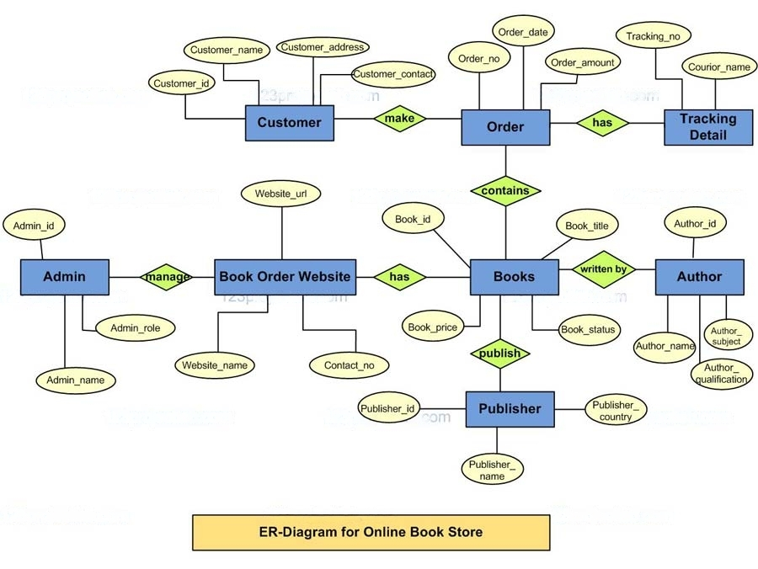

#### **Entities and Attributes:**

* **User (Customer/Administrator):**
  + _id (PK): Unique identifier for the user.
  + name: Full name of the user.
  + email: User's email address.
  + password: Hashed password for user authentication.
  + role: Defines the user's role (customer/administrator).
* **Book:**
  + _id (PK): Unique identifier for each book.
  + title: Title of the book.
  + author: Author of the book.
  + genre: Genre or category of the book.
  + price: Price of the book.
  + stock: Quantity of the book available in stock.
  + description: A short description of the book.
* **Order:**
  + _id (PK): Unique identifier for the order.
  + userId (FK): References the user who placed the order.
  + totalPrice: The total price of the order.
  + status: The current status of the order (e.g., "pending", "shipped", "delivered").
  + orderDate: The date the order was placed.
* **OrderItem:**
  + _id (PK): Unique identifier for the order item.
  + orderId (FK): References the order.
  + bookId (FK): References the book in the order.
  + quantity: Number of copies of the book ordered.
  + price: Price of the book at the time of the order.

#### **Relationships:**

* **User to Order:**
  + One user (customer) can place many orders (One-to-Many).
  + A customer can have multiple orders over time, but each order belongs to one specific customer.
* **Book to OrderItem:**
  + One book can appear in many order items (One-to-Many).
  + A book can be part of multiple orders, but each order item references only one book.
* **Order to OrderItem:**
  + One order can have many order items (One-to-Many).
  + An order can contain multiple books, each represented as an order item.
* **User to Book (via Order):**
  + Many users can order many books, and many books can be ordered by many users (Many-to-Many via OrderItem).
  + This is modeled through the Order and OrderItem entities, allowing users to purchase multiple books in a single order.

### **Collections:**

#### **Users:**

* **Stores basic user details**, including role-based data (customer or administrator), facilitating access control.
  + Attributes: _id, name, email, password, role (customer/administrator), address, phone number.

#### **Books:**

* **Stores book details** such as title, author, price, stock, and genre.
  + Attributes: _id, title, author, genre, price, stock, description, image.

#### **Orders:**

* **Manages order information**, including customer ID, order date, total price, and status fields (e.g., "pending", "shipped").
  + Attributes: _id, userId, totalPrice, status, orderDate.

#### **OrderItems:**

* **Manages individual items in an order**, linking books to orders and recording quantities and prices.
  + Attributes: _id, orderId, bookId, quantity, price.

### **Data Flow:**

* **When a customer places an order**, a document is created in the **Orders** collection, linking to the **User** (customer) and containing details like the total price and order status.
* **Each order** can contain multiple **OrderItems**, where each item links to a **Book** and records the quantity purchased and the price of the book at the time of the order.
* **Inventory management**:

When an order is placed, the stock of the books is updated in the **Books** collection to reflect the new quantities available.

### **5. System Components:**

#### **Frontend (React.js):**

The frontend is developed using **React.js**, which creates a component-based structure for building reusable, modular elements. The main pages include:

* **Login and Registration:**
  + Allows users to create accounts or access existing ones. Customers can register and log in to view their profiles and place orders, while administrators can log in to manage inventory and order statuses.
* **Dashboard:**
  + The main interface where users can view or manage their orders and browsing history. Customers can also check their order status here.
* **Profile Management:**
  + Provides an interface for updating personal details and preferences, such as shipping address and contact information.
* **Book Search and Browsing:**
  + Customers can browse books by genre, title, or author. The page includes filters for price range and stock availability.
* **Shopping Cart:**
  + Allows customers to add books to their cart, view quantities, and proceed to checkout.
* **Order Checkout:**
  + Customers can review their cart, add payment information, and finalize their orders.

#### **State Management:**

* **Redux** is employed for managing the global state, including user authentication, shopping cart data, and order status. Redux simplifies sharing data across components and ensures the state is consistent across the app, even during page refreshes.

#### **HTTP Requests with Axios:**

* **Axios** is used to communicate with the **Express.js** backend, sending data like login credentials, book searches, order requests, and profile updates.

#### **UI Libraries:**

* **Ant Design** and **Bootstrap** are used to provide pre-designed components such as buttons, forms, grids, modals, and navigation bars. These ensure a responsive and visually consistent user interface, making it easier to manage the layout for both customers and administrators.

### **6. Security Features:**

#### **JWT Authentication:**

* **JWT (JSON Web Token)** is used for secure user authentication. When a user logs in, a token is generated containing encoded user information and a signature. This token is stored on the client side (typically in local storage or a cookie) and sent with each request to the backend for verification.
* **Token-Based Authentication** helps ensure that only authenticated users can access certain routes and resources, such as placing orders or updating personal information.

#### **Code for Token Generation:**

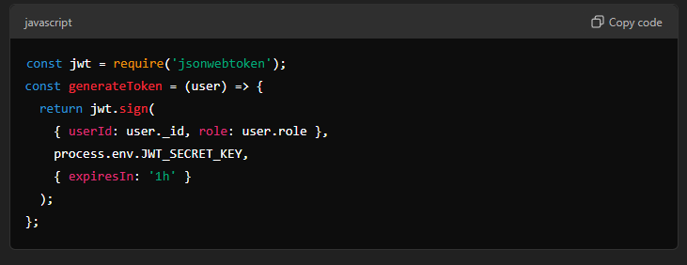

#### **Role-Based Access Control (RBAC):**

* **Role-based access control** is implemented by checking the user’s role within the JWT. Depending on whether the user is a **customer** or an **administrator**, they will have different permissions.
* **Customers** can place orders, update their profiles, and view order history, while **administrators** can manage inventory, update book details, and view all orders.
* Middleware functions enforce role-based checks before route access.

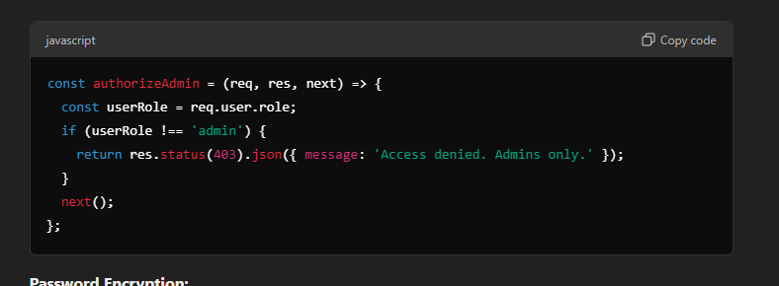

#### **Password Encryption:**

* **Passwords** are hashed using **bcrypt** before being stored in the database. This ensures that even if the database is compromised, passwords remain protected as bcrypt hashes cannot be easily reversed.

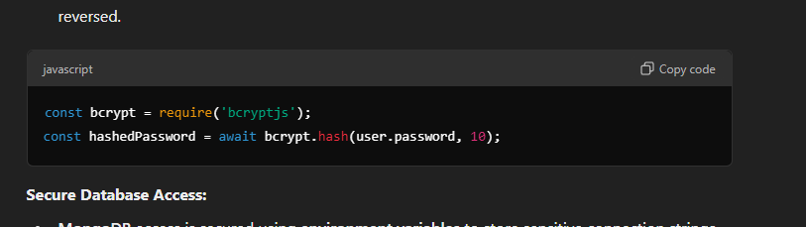

#### **Secure Database Access:**

* **MongoDB** access is secured using **environment variables** to store sensitive connection strings and credentials, ensuring that they are not exposed in the codebase.
* **Access to sensitive data** (like passwords and tokens) is encrypted and transmitted over **HTTPS** to prevent interception.

### **7. User Interface Design:**

#### **Wireframes:**

* **Wireframes** for key pages such as **Login**, **Profile Management**, **Book Search**, **Shopping Cart**, and **Order Checkout** were created during the design phase. These wireframes ensure that the layout is intuitive and user-friendly, with elements like buttons, navigation menus, and product images properly placed for easy interaction.

#### **Responsive Design:**

* **Mobile-first design** is adopted to ensure that the interface works seamlessly across devices of all sizes. The layout is built with **media queries** and utilizes **Bootstrap's responsive grid system** to adjust the UI based on the screen size.

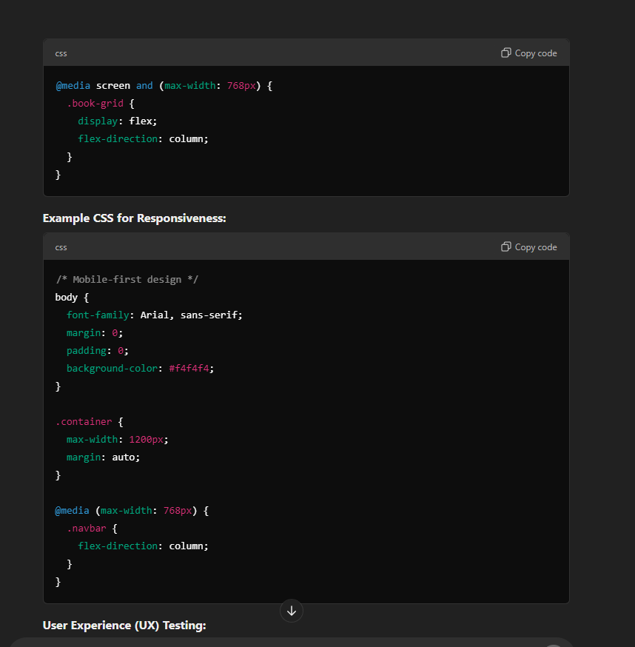

@media screen and (max-width: 768px) {

.book-grid {

display: flex;

flex-direction: column;

}

}

#### **Example CSS for Responsiveness:**



/* Mobile-first design */  
body {  
 font-family: Arial, sans-serif;  
 margin: 0;  
 padding: 0;  
 background-color: #f4f4f4;  
}  
  
.container {  
 max-width: 1200px;  
 margin: auto;  
}  
  
@media (max-width: 768px) {  
 .navbar {  
 flex-direction: column;  
 }  
}

#### **User Experience (UX) Testing:**

* **UX testing** was conducted to assess usability, ease of navigation, and overall flow. Testers simulated various scenarios, such as searching for books, adding items to the shopping cart, checking out, and managing user profiles. The goal was to identify pain points and improve the user journey.
* Feedback was gathered from both customers and administrators to ensure the system met their needs.

#### **Accessibility Considerations:**

* The design incorporates accessibility features to ensure that the interface is usable by **visually impaired users**. This includes:
  + Screen reader-friendly elements, such as properly labeled buttons, forms, and headings.
  + Keyboard navigation support for users who cannot use a mouse.

#### **UI Libraries:**

* **Ant Design** and **Bootstrap** are utilized to enhance the look and feel of the user interface. Pre-designed components like **buttons**, **forms**, **modals**, and **grids** make it easy to maintain a polished, consistent layout across all pages.
* These libraries also include responsive design features, ensuring the interface adjusts well on mobile, tablet, and desktop devices.

### **8. API Design:**

#### **RESTful API Endpoints:**

The backend exposes RESTful APIs to handle **user authentication**, **book inventory management**, **order placement**, and **shopping cart management**. Each API follows the HTTP method conventions: **GET** (retrieve), **POST** (create), **PUT** (update), **DELETE** (remove).

#### **Sample API for Book Management:**

* **POST /books**: Allows an admin to add a new book to the bookstore.
* **GET /books**: Retrieves a list of books available in the store.
* **GET /books/**: Fetches the details of a specific book by its ID.
* **PUT /books/**: Updates details of a specific book (e.g., price, stock).
* **DELETE /books/**: Deletes a specific book from the inventory.

#### **Sample API for Order Management:**

* **POST /orders**: Allows a customer to place a new order.
* **GET /orders/**: Fetches the details of a specific order by its ID.
* **PUT /orders/**: Updates the status of an order (e.g., from pending to shipped).
* **DELETE /orders/**: Cancels an existing order.

#### **Diagram:**

The following diagram illustrates how the API endpoints interact with the **frontend** and the **backend** to manage books, orders, and users:

* **Frontend**: Makes API requests for browsing books, adding to the cart, and placing orders.
* **Backend**: Processes requests, interacts with the database, and returns appropriate responses.
* **Database**: Stores book information, order details, and user profiles.

#### **API Authentication:**

* Each API request requires a **valid JWT token** in the **authorization header** to access protected routes like placing orders, updating book details, and managing user accounts.

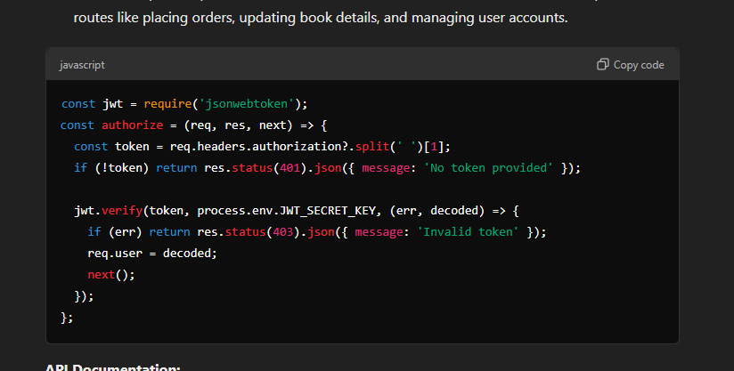

const jwt = require('jsonwebtoken');  
const authorize = (req, res, next) => {  
 const token = req.headers.authorization?.split(' ')[1];  
 if (!token) return res.status(401).json({ message: 'No token provided' });  
   
 jwt.verify(token, process.env.JWT_SECRET_KEY, (err, decoded) => {  
 if (err) return res.status(403).json({ message: 'Invalid token' });  
 req.user = decoded;  
 next();  
 });  
};

#### **API Documentation:**

* API documentation is automatically generated using tools like **Swagger**, which provides interactive documentation and examples, making it easy for frontend developers or external services to understand how to use the backend API.

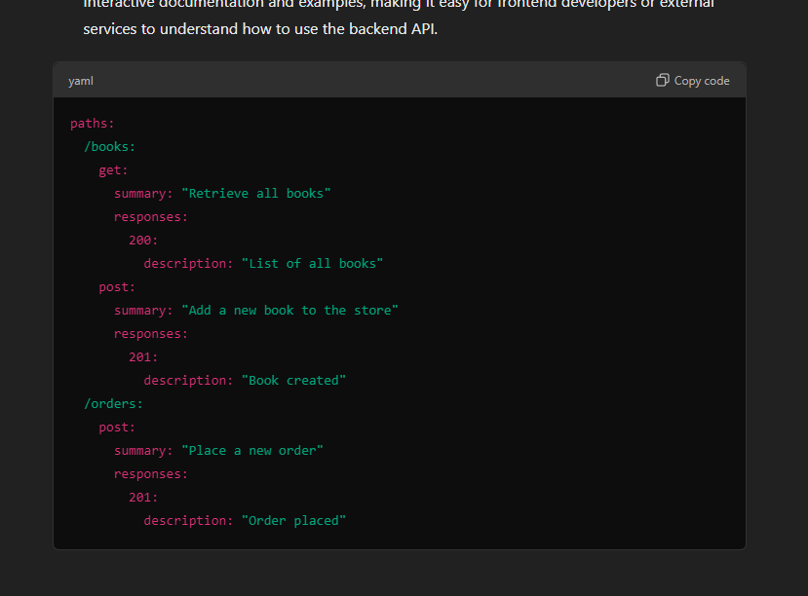

yaml

paths:  
 /books:  
 get:  
 summary: "Retrieve all books"  
 responses:  
 200:  
 description: "List of all books"  
 post:  
 summary: "Add a new book to the store"  
 responses:  
 201:  
 description: "Book created"  
 /orders:  
 post:  
 summary: "Place a new order"  
 responses:  
 201:  
 description: "Order placed"

### **9. Implementation:**

The implementation phase involved setting up the development environment, coding the frontend and backend features, and integrating the database. The project was divided into the following steps:

#### **Frontend Implementation:**

* Developed the **user interface** using **React.js**, including pages such as **home**, **book details**, **cart**, and **order checkout**. These UI components interact with the backend via API calls to retrieve and manage book data, handle user authentication, and process orders.

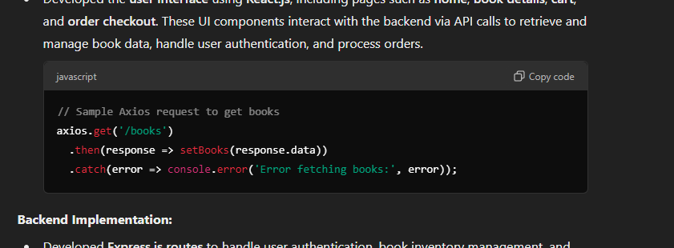

#### **Backend Implementation:**

* Developed **Express.js routes** to handle user authentication, book inventory management, and order processing. Each route interacts with the database to retrieve or update the necessary data.

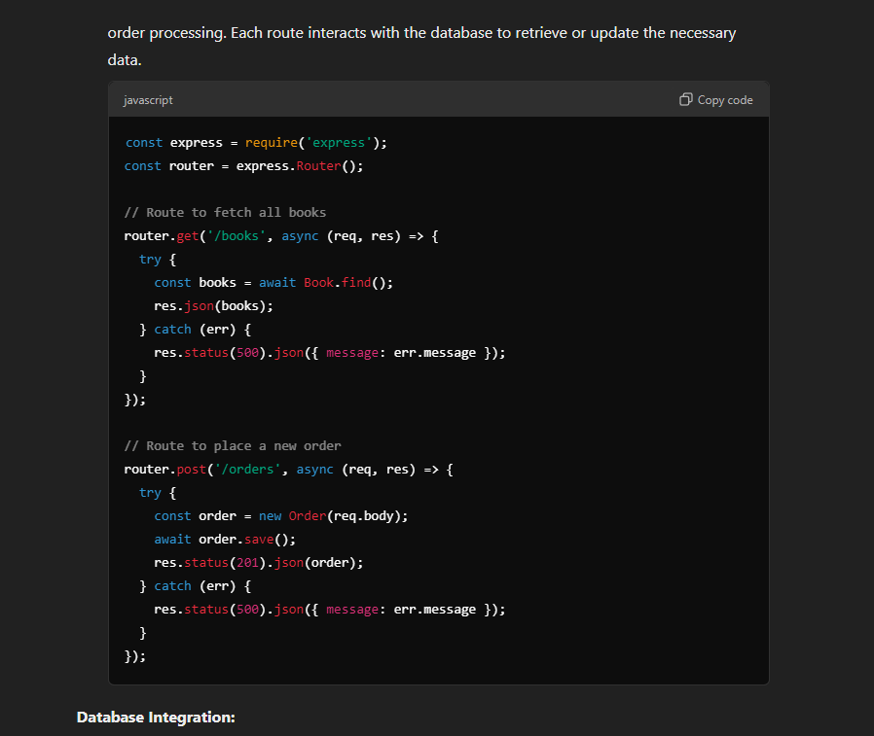

#### **Database Integration:**

* **MongoDB collections** were created for **users**, **books**, and **orders**. We used **Mongoose ORM** to simplify database interactions, including schema definitions and CRUD operations.

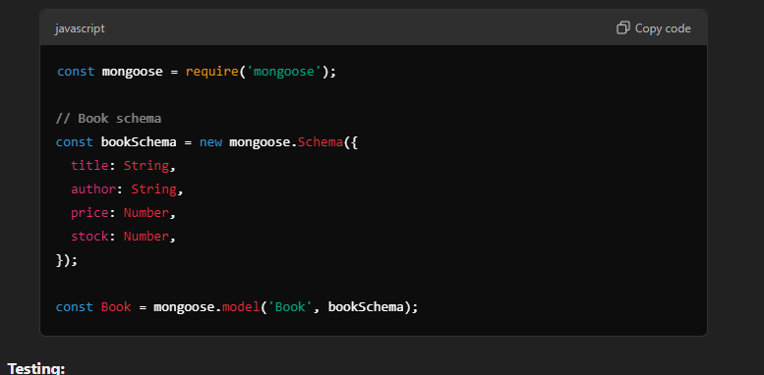

#### **Testing:**

* **Unit tests** were written for individual components like the **book catalog** and **order processing** logic. **Integration tests** ensured that the entire system worked as expected, simulating real user behavior such as searching for books, adding them to the cart, and completing a purchase.

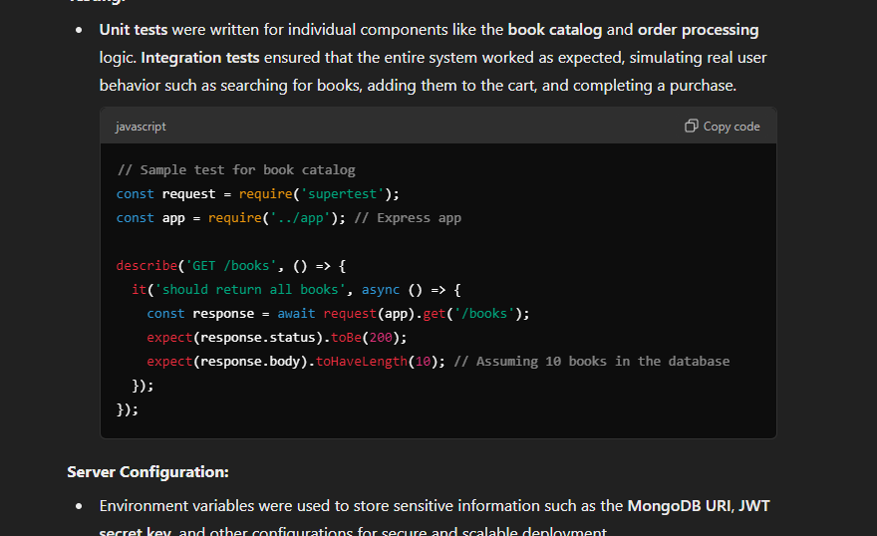

#### **Server Configuration:**

* Environment variables were used to store sensitive information such as the **MongoDB URI**, **JWT secret key**, and other configurations for secure and scalable deployment.

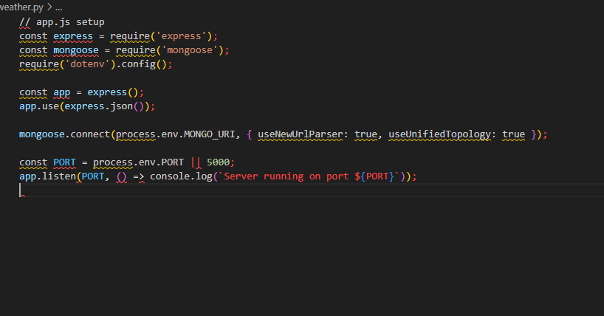

### **10. Testing:**

#### **Types of Testing:**

* **Unit Testing:**
  + Unit testing focuses on testing individual components or units of code to ensure they function correctly in isolation. Each unit (such as a function or a module) is tested by providing specific inputs and checking if the output is correct. This type of testing helps detect bugs early and ensures that every small part of the system is working as expected.
  + **Example:**
    - For the **BookList** component in React, unit tests can be written to check if the component renders correctly, handles events like adding books to the cart, and manages state updates (such as the book count).
* **Integration Testing:**
  + Integration testing ensures that different modules or components of the application work together as expected. While unit tests focus on individual components, integration tests validate the interactions between them. For example, when a user places an order, integration testing would check if the interaction between the frontend (React), backend (Express), and database (MongoDB) functions correctly.
  + **Example:**
    - In the case of placing an order, an integration test can ensure that when an order is placed, the data flows from the frontend to the backend, the stock is updated in the database, and an order confirmation is generated.
* **End-to-End Testing:**
  + End-to-end testing is the process of testing the complete workflow of the application, from start to finish, to ensure that all components and interactions work as expected in a real-world scenario. This involves simulating user actions such as logging in, browsing books, adding to the cart, placing an order, and confirming the order.
  + **Example:**
    - Testing the entire flow of placing an order, including user registration, book search, adding to the cart, proceeding to checkout, and order confirmation.

#### **Testing Tools:**

* **Jest**: Used for unit tests of React components.
* **Mocha**: Used for backend testing with Express.js routes.
* **Supertest**: Used for testing API routes in Express.
* **Postman**: Used for manual API testing and testing complex API requests.
* **Cypress**: Used for end-to-end testing to simulate user interactions and verify the overall workflow.

#### **Unit Tests for Components:**

Tests using **Jest** for front-end components, such as:

* Checking if the **BookList** component renders books correctly.
* Verifying if the **Cart** component updates when items are added or removed.
* Ensuring **OrderForm** validates input and triggers the correct order submission.

#### **Integration Tests:**

Tests using **Supertest** to verify:

* That the **book creation route** correctly adds new books to the database.
* That the **order route** properly processes the order, interacts with the database, and sends the correct response.
* That **user authentication routes** correctly issue and validate JWT tokens.

#### **Test Cases for the Bookstore System:**

|  |  |  |  |
| --- | --- | --- | --- |
| **Test Case ID** | **Test Description** | **Expected Result** | **Status** |
| **TC01** | **User Registration** | User successfully registers with valid input. | Pass/Fail |
| **TC02** | **User Login** | User logs in with correct credentials and is redirected to the dashboard. | Pass/Fail |
| **TC03** | **User Login with Invalid Credentials** | User sees an error message for invalid credentials. | Pass/Fail |
| **TC04** | **Search for Books** | User can search and view books in the catalog. | Pass/Fail |
| **TC05** | **Add Book to Cart** | User can add a book to their cart successfully. | Pass/Fail |
| **TC06** | **View Cart** | User can view the items added to the cart. | Pass/Fail |
| **TC07** | **Place an Order** | Order is successfully placed, and confirmation is received. | Pass/Fail |
| **TC08** | **Admin Views All Books** | Admin can view a list of all books available in the bookstore. | Pass/Fail |
| **TC09** | **Admin Adds a New Book** | Admin can successfully add a new book to the bookstore. | Pass/Fail |
| **TC10** | **JWT Authentication (Valid Token)** | The system grants access to protected routes when the token is valid. | Pass/Fail |
| **TC11** | **JWT Authentication (Invalid Token)** | System returns an error for invalid or expired tokens. | Pass/Fail |
| **TC12** | **Password Hashing and Salting** | Password is stored as a hashed value, not plain text. | Pass/Fail |
| **TC13** | **Database Interaction** | Data is properly inserted and queried from MongoDB (books, orders). | Pass/Fail |
| **TC14** | **Frontend Responsiveness** | UI elements adapt to different screen sizes (desktop, tablet, mobile). | Pass/Fail |
| **TC15** | **End-to-End Test (Search, Cart, Checkout)** | Full flow: User searches for books, adds to cart, and places an order. | Pass/Fail |

### **11. Deployment:**

The deployment process involves preparing the bookstore application for production, making it publicly accessible, and ensuring its stability across devices and users. It also includes the setup of cloud services and CI/CD pipelines to manage updates and scaling.

#### **Deployment Steps:**

**Prepare the Application for Deployment:**

* Run npm run build for the React frontend, ensuring that the build is optimized for production with minification and other performance improvements.

**Choose Hosting Platform:**

* **Frontend Deployment**:
  + Platforms like **Netlify** or **Vercel** can be used for easy deployment of the static React application.
* **Backend Deployment**:
  + Use cloud platforms like **Heroku**, **AWS Elastic Beanstalk**, or **DigitalOcean** to deploy the Express backend server.

**Database Hosting:**

* Use **MongoDB Atlas** or **AWS** for hosting MongoDB in the cloud. These services ensure scalability, automatic backups, and high availability.

**CI/CD Configuration:**

* Automate the deployment process using CI/CD tools like **GitHub Actions**, **CircleCI**, or **GitLab CI**. This allows for continuous integration and delivery whenever changes are pushed to the repository.

**Deploy Frontend:**

* Upload the build files to **Netlify**, **Vercel**, or **AWS S3**. These platforms handle static content efficiently and provide built-in deployment pipelines.

**Deploy Backend:**

* The backend can be deployed using **Heroku** or **AWS Elastic Beanstalk**, which offer scalable deployment solutions with easy management.

**Environment Variables:**

* Configure environment variables for production, such as database connection strings, secret keys for JWT tokens, and API keys, ensuring they are kept secure.

**SSL Configuration:**

* Set up **SSL certificates** to ensure secure **HTTPS** access for all users, enhancing security and trustworthiness.

**Monitoring and Scaling:**

* Use tools like **AWS CloudWatch**, **Datadog**, or **New Relic** to monitor the application’s performance and ensure automatic scaling based on traffic.

**Configure Domain:**

* Set up custom domains with DNS management, ensuring the application can be accessed through a personalized URL.

**Final Testing:**

* Test the live application in different environments to ensure all features work as expected, including book search, cart functionality, user login, and checkout.

### **12. Challenges and Solutions:**

**Data Consistency:**

* Managing data consistency in MongoDB, especially during high traffic and simultaneous book orders, can become challenging.

**Solution:**

* To maintain consistency during transactions, especially for stock updates and order processing, we implemented **MongoDB transactions**. This ensures atomic operations for tasks like placing an order or updating stock quantities.

**Role-Based Access Control (RBAC):**

* Ensuring that users (admins, customers) only access their permitted functionality, such as book management for admins and ordering for customers.

**Solution:**

* We included a **role claim** within the **JWT** token that’s checked on the server side. Middleware is used to ensure only authorized users can access certain routes (e.g., admins can add or manage books, while customers can only view and purchase books).

**Handling Different Currencies/Prices:**

* Converting and storing book prices in different currencies, especially if the bookstore operates internationally.

**Solution:**

* Leveraged **currency conversion APIs** to provide real-time conversion rates and ensure accurate price representation. All prices are stored in the database in a base currency, with conversions happening dynamically at the frontend.

**Responsive UI Across Devices:**

* Ensuring that the bookstore application is fully functional and visually appealing across a wide range of devices, from mobile phones to large desktop screens.

**Solution:**

* Used **Bootstrap** and **CSS media queries** to create a responsive layout. The design dynamically adjusts depending on the screen size, ensuring a seamless experience across mobile, tablet, and desktop views.

### **13. Future Enhancements:**

**Real-Time Notifications:**

* Integrate notifications for order status updates, shipping confirmations, and new book arrivals to keep users informed.

**Book Recommendations System:**

* Implement an AI-driven recommendation system to suggest books based on user preferences, past purchases, or browsing history.

**User Reviews and Ratings:**

* Allow users to rate books and leave reviews, enabling future buyers to make informed purchasing decisions.

**Advanced Search Filters:**

* Implement advanced filtering options for book searches based on genre, author, price range, rating, and more.

**Multi-User Role Support:**

* Add additional roles such as store managers, staff, and suppliers to handle inventory management, product updates, and order fulfillment.

### **14. Conclusion:**

**Project Summary:**

The Bookstore System provides a platform where users can browse, search, and purchase books seamlessly. It enables easy management of inventory and orders for store administrators, while customers can effortlessly browse books and complete purchases. The application successfully implements core features such as secure login, role-based access control, and a responsive UI.

**Key Achievements:**

* The system’s architecture is modular, allowing for scalability and easy maintenance. The separation of concerns between the frontend, backend, and database layers ensures clear boundaries and makes it easier to extend the system in the future.
* The user interface is designed with simplicity and ease of use in mind. By leveraging modern web technologies like React, the application provides an interactive and responsive experience for users, making it easy for them to browse books, search for titles, and manage their accounts.
* The database schema was designed to handle relationships between books, users, and orders. Using normalization techniques ensures data integrity, while foreign key constraints maintain referential integrity.
* Robust security features like encrypted passwords, JWT authentication, and data validation mechanisms were implemented to safeguard user data and ensure privacy. The system includes user roles (admin, customer) with appropriate access control to ensure only authorized actions can be performed.
* A comprehensive testing approach was adopted, including unit tests, integration tests, end-to-end (E2E) tests, and API tests. Tools like Jest, React Testing Library, Cypress, Postman, and Apache JMeter were employed to ensure quality and reliability.

**Reflection and Final Thoughts:**

* The Bookstore Management System project has been an invaluable learning experience, allowing me to apply theoretical knowledge in a real-world context while addressing various technical, operational, and design challenges. Working on this project, particularly using the MERN stack, has deepened my understanding of full-stack development, as well as the integration of both frontend and backend components.
* A key takeaway from this project has been the importance of a user-centered design. Understanding the needs of bookstore customers helped me design an intuitive interface that simplifies browsing, purchasing, and managing orders. The goal was to create a seamless user experience, ensuring that customers could navigate the system easily, find books quickly, and complete purchases with minimal effort.
* The project also underscored the importance of security, especially in an e-commerce setting. By implementing JWT authentication, password encryption with bcrypt, and role-based access control (RBAC), I ensured that sensitive user data remains secure. The legal and ethical considerations around handling financial data and personal information were also considered during development.
* In conclusion, this project has not only helped me develop a functional and scalable bookstore system but also enhanced my technical abilities and understanding of real-world software development practices. Moving forward, I plan to introduce features like personalized book recommendations, real-time notifications, and more detailed user reviews, which will further enhance the platform's value and user experience.

### **15. References:**

* MongoDB (Database): <https://docs.mongodb.com/>
* Express.js (Backend Framework): <https://expressjs.com/>
* React.js (Frontend Framework): <https://reactrouter.com/>
* Node.js (Runtime Environment): <https://www.youtube.com/watch?v=TlB_eWDSMt4>
* JSON Web Tokens (JWT) for Authentication: <https://jwt.io/>
* Git & Version Control: <https://git-scm.com/doc>
* Deployment (e.g., Heroku or AWS): <https://docs.aws.amazon.com/ec2/index.html>
* Testing Frameworks: <https://mochajs.org/>
* CSS Frameworks for Styling (Optional, e.g., Bootstrap): <https://mui.com/>